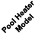 |  |  |  |  |  |  |  |  |  | 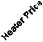
  Jandy / Laars Lite 2 Heater  Jandy LX Series Heater  Jandy Hi-E2 Heater  Jandy Air Energy Heat Pump  Jandy LXi Low NOx Heater  Jandy Legacy Heater  Jandy Legacy Millivolt | Laars Lite 2 Heater |  | 1 Yr. | Yes |  | Yes | 82% | Natural /  Propane | Yes | Yes | NLA
 | Jandy LX Series Heater |  | 1 Yr. | Yes |  | Yes | 83% | Natural /  Propane | Yes | Yes | NLA
 | Laars XL-3 Heater |  | 1 Yr. | No |  | Yes | N/A | Oil | No | Yes | NLA
 | Jandy Hi-E2 Heater |  | 1 Yr. | Yes |  | No | 95% | Natural /  Propane | Yes | Yes | $6063.55
 | Jandy Air Energy Heat Pump |  | 1 Yr. | Yes |  | No | N/A | Electric | Yes | Yes | $3397.97
 | LXi Low NOx Heater | 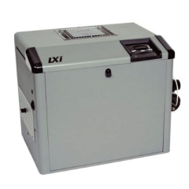 | 1Yr | Yes | 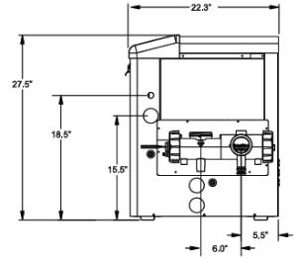 | Yes | 88% | Natural /  Propane | Yes | Yes | $2010.68
 | Legacy Heater |  | 1Yr | Yes |  | Yes | 83% | Natural /  Propane | No | No | $1347.45
 | Legacy Millivolt Heater |  | 1Yr | No |  | Yes | 83% | Natural /  Propane | No | No | $1228.38
  Lochinvar EnergyRite Heater | EnergyRite Nat. Gas Heater | 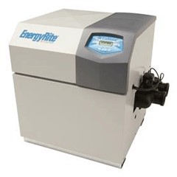 | 2 Yr. | Yes | N/A | Yes | 88% | Natural / Propane | Yes | Yes | $2010.49
  Raypak Digital Heater  Raypak Millivolt Heater  Raypak Heat Pump  Raypak Digital Low NOx Heater  Raypak D-2 Power Vents | Raypak Digital Heater |  | 1 Yr. | Yes |  | Yes | 82% | Natural /  Propane | No | Yes | $1646.30
 | Raypak Millivolt Heater |  | 1 Yr. | Yes |  | Yes | 82% | Natural /  Propane | No | No | $1474.59
 | Raypak Heat Pump |  | 5 Yr. | Yes |  | No | N/A | Electric | Yes | Yes | $2561.48
 | Raypak Digital Low NOx Heater |  | 1 Yr. | Yes |  | Yes | 82% | Natural | Yes | Yes | $1667.97
  Purex Minimax 100 Heater  Purex MiniMax 75 Heater  Purex Minimax NT Heater  MasterTemp Low NOx Heater | Purex Minimax 100 Heater |  | 1 Yr | No |  | Yes | N/A | Natural /  Propane | No | No | $1042.87
 | Purex Minimax 75 Heater |  | 1 Yr | No |  | Yes | 80% | Natural | Yes | No | $1032.21
 | Purex Minimax NT Heater |  | N/A | N/A | N/A | N/A | N/A | N/A | N/A | N/A | NLA
 | MasterTemp Heaters | 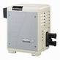 | 2Yr | Yes | 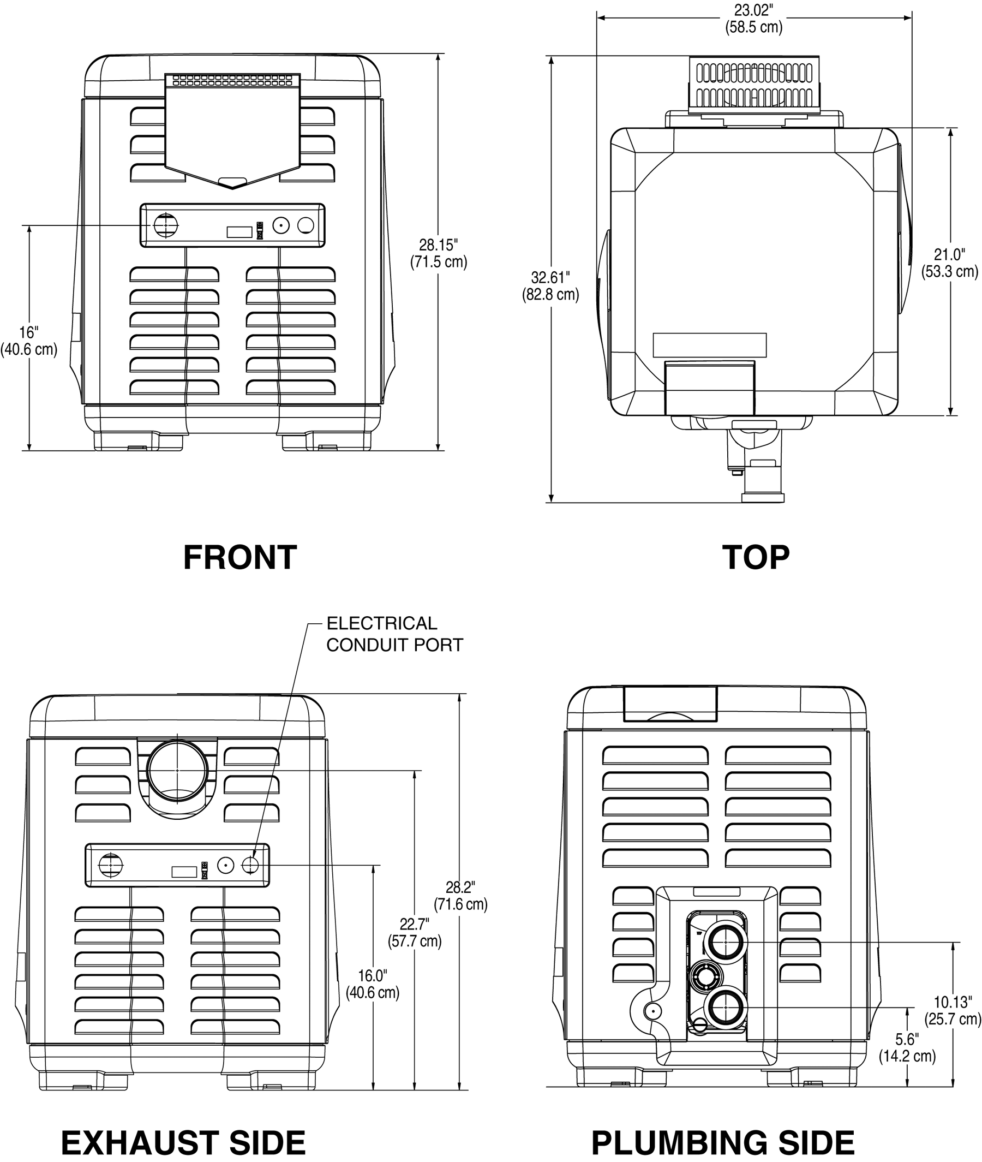 | Yes | 82% | Natural /  Propane | Yes | Yes | $1702.29
Sta-Rite Max-E-Therm Heater | Sta-Rite Max-E-Therm Heater |  | 2 Yr. | Yes |  | No | 84% | Natural /  Propane | Yes | Yes | $1802.51
  Aqua Pro A/G Heat Pump  Aqua Pro I/G Heat Pump | Aqua Pro A/G Heat Pump |  | 5 Yr. | No | N/A | No | N/A | Electric | N/A | Yes | $2247.97
 | Aqua Pro I/G Heat Pump | 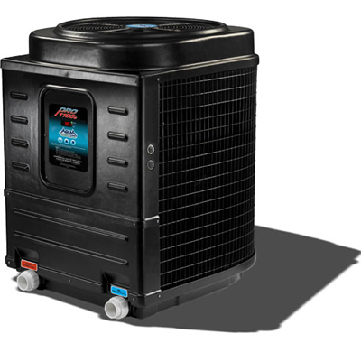 | 15 Yr. | Yes | N/A | No | N/A | Electric | N/A | Yes | $3387.97
  Hayward-Universal H-Series  Hayward H-Series Millivolt  Hayward H-Series Above Ground | Universal H-Series Heaters | 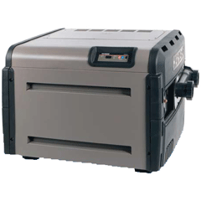 | 1Yr | Yes |  | Yes | 84% | Natural /  Propane | Yes | Yes | $1469.81
 | H-Series Millivolt Heaters |  | 1Yr | No |  | Yes | 81% | Natural /  Propane | No | No | $1386.19
 | H-Series Above Ground |  | 1Yr | No |  | No | 81% | Natural /  Propane | Yes | No | $1008.29

